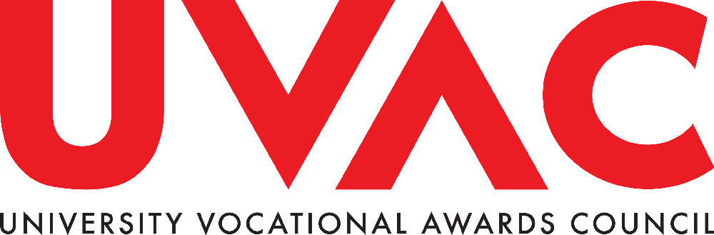

Senior Leader Apprenticeship – Nine Arguments why Government Should Ensure that Employers continue to be able to Fund Senior Leader Apprenticeships from Apprenticeship Levy Funds and the Department for Education Apprenticeship Budget – For repurposing and/or using verbatim.

Some in Westminster Government and the opposition parties are apparently questioning the appropriateness of allowing employers to use apprenticeship levy funds/the apprenticeship budget to pay for Senior Leader Apprenticeships. UVAC outlines nine reasons why the Senior Leader Apprenticeship should continue to be funded from the levy and the apprenticeship budget.

UVAC members and stakeholders may wish to make reference to these arguments and similar CMI arguments in discussion with ministers, shadow ministers, MPs and civil servants. HEIs are also asked to request that appropriate employers make similar arguments, offer supportive quotations and demonstrate the value of the Senior Leader Apprenticeship to their organisations, in their representation to Westminster Government.

1. Senior Leader Apprenticeships are Affordable for Government - In the 2022/23 financial year £3,580 million was raised through the apprenticeship levy, £608 million was allocated to the devolved Governments, leaving £2,972 million of levy funds, of which £2,554 million was allocated to the apprenticeship budget for England. The actual apprenticeship budget of £2,554 million was under-spent by £96 million. Monies raised by government through the apprenticeship levy, even after allocations to the devolved administrations, substantially exceed the apprenticeship budget and monies spent on Apprenticeships. Senior Leader Apprenticeships accounted for just 1.6% of all apprenticeship starts in 2022/23. Apprenticeships at level 2 and 3 for young people and Senior Leader Apprenticeships can both be afforded. From a government/HMT budgetary perspective there is no need to restrict employer spending on Senior Leader Apprenticeships.

2. Senior Leader Apprenticeships are Used Most Extensively in the Public Sector, particularly the NHS and are a Key Component in Plans to Raise Public Sector Productivity – The majority of Senior Leader Apprenticeships, 61%, are used in the public sector. Here Senior Leader Apprenticeships are an integral part of strategies to raise public sector performance and productivity and tackle key performance issues in for example the NHS long-term Workforce Plan. Senior Leader Apprenticeships in the public sector support the delivery of essential public sector services.

3. Senior Leader Apprenticeships are not “Deadweight Apprenticeships” – In the public sector Senior Leader Apprenticeships would not have taken place without the Apprenticeship Levy. If levy funding/access to the apprenticeship budget was withdrawn, there are unlikely to be alternative funding or budgets through which to fund such vital management training and development programmes. Also, why should employers who previously invested in training their staff be penalised for utilising and optimising their levy payment or co-investment?

4. Removal of Funding for the Senior Leader Apprenticeship Will Alienate Employers – Employers frequently complain they cannot use the Apprenticeship Levy funds they pay and that apprenticeships are too restrictive. Restricting spend on the Senior Leader Apprenticeship will further alienate employers and employer representative organisations, particularly in the NHS and public sector more broadly.

5. Removal of Levy Funding for the Senior Leader Apprenticeship would be Seen as the Thin End of the Wedge for Level 6 and 7 Apprenticeships and Create Uncertainty in the Market – The appropriateness of allowing employers to spend apprenticeship levy funds on the Senior Leader Apprenticeship usually involves arguments that such Apprentices are relatively well-paid and will secure even better paid jobs on completion. The same argument could be applied to Digital and Technology Solutions Professional, Systems Engineer Apprenticeships and even some public sector Apprenticeships, Doctors, for example. If employers were prevented from using Levy payments to fund the Senior Leader Apprenticeship would Apprenticeships for other level 7 (or level 6) occupations be next in line for such treatment?

Removal of levy funding for the Senior Leader Apprenticeship would create uncertainty and destabilise the apprenticeship market. Such uncertainty would come at a time when government is trying to increase apprenticeship numbers and grow HEI investment in degree apprenticeship provision.

6. If Apprenticeship is a Productivity Focused Programme, Funding Senior Leader Apprenticeships through the Levy is Essential – Low productivity and low growth in productivity is arguably the biggest economic challenge facing the UK. The CMI report by John Van Reenen and Nicholas Bloom of the World Management Survey suggest that more than half of the productivity gap between the UK and America can be attributed to poor management practice. If apprenticeships are to play a major part in tackling poor UK productivity a focus on management roles, including senior leaders is essential.

7. Senior Leadership Apprenticeship Can Support Social Mobility, Inclusion and Workforce Diversity – Senior Leadership Apprenticeships represent a new way to recruit and train business and organisation leaders. They should have a key role in supporting social mobility and increasing workforce diversity. According to the CMI three in five senior leader apprentices come from the 50% most deprived areas in the UK.

8. Supporting Senior Leader Apprenticeships Demonstrates the Government’s Commitment to the Importance of Life Long Learning – If Apprenticeships and the apprenticeship levy are to have the maximum impact on raising productivity and enhancing social mobility, apprenticeships must remain an ALL age and ALL level programme. Developing the skills and occupational competence of the existing workforce is just as important as developing the skills of young people entering the workforce. Supporting opportunities for individuals to progress into senior leadership roles should be a key offer of the apprenticeship programme.

9. Restricting Levy Funding for the Senior Leader Apprenticeship Would Suggest Whitehall Not Employers Know Best on the training needed by the Workforce – The apprenticeship levy and related apprenticeship reforms were introduced by the government to ensure that apprenticeships were an employer-led programme. Government believed that employers and not Whitehall knew best what skills and programmes organisations needed to raise performance and productivity.

The Issues to Tackle – The main ‘problem’ with the Senior Leader Apprenticeship concerns image and perception. The caricature of the investment banker, or well-paid FTSE executive using levy funds to pay for an MBA and denying a young person funding for an Apprenticeship to secure their first job has, in the past, featured in the debate on apprenticeship focus. The reality is, however, very different. Nearly 60% of Senior Leader Apprenticeships are undertaken in the public sector, with the NHS being the most prolific user of such programmes. Middlesex University reported that 94% of its Senior Leader Apprenticeship worked in the public sector. The MBA element of the Senior Leader Apprenticeship was also removed in 2020. Government could change this false perception by working with employers, employer representative organisations and higher education providers to demonstrate and promote the value of the Senior Leader Apprenticeship, particularly in the NHS and wider public sector.

Improvements in the delivery of Senior Leader Apprenticeships could, of course, be made. More could also be done to support SMEs to use the Senior Leader Apprenticeship.

Removing Levy Funding/Apprenticeship Budget for the Senior Leader Apprenticeship will not solve any existing problem for government but risks creating many new problems and will further alienate employers from the apprenticeship levy. Ongoing, the debate is about what the purpose of an apprenticeship in England should be.

The Critical Contribution of Level 6/7 Management Apprenticeships, CMI 2023
Mandy Crawford-Lee, ‘Every pound raised through the levy should be spent on apprenticeships’, FE Week, 3 November 2023 https://feweek.co.uk/every-pound-raised-through-the-levy-should-be-spent-on-apprenticeships/

